The Academic Doctoral Qualification Examination
博士资格考试
1.1. To Submit Doctoral Qualification Examination Application
Operation Steps
Log in to the system, click on [培养环节] → [博士资格考试申请Doctoral Qualification Examination Application] → [博士资格考试申请].
Operation Instructions
The following is the page for the doctoral qualification examination application.
Click [申请] to maintain the application content, click [保存] to save the application content; click [提交] to submit the application.
For saved applications, click [编辑] in the operation column to modify the application, or click [删除] to delete the application.
For submitted applications, students can check the review progress by moving the mouse over the review status, click [查看] in the operation column to view the application. If the supervisor has not reviewed it, students can click [撤回] to withdraw the application.
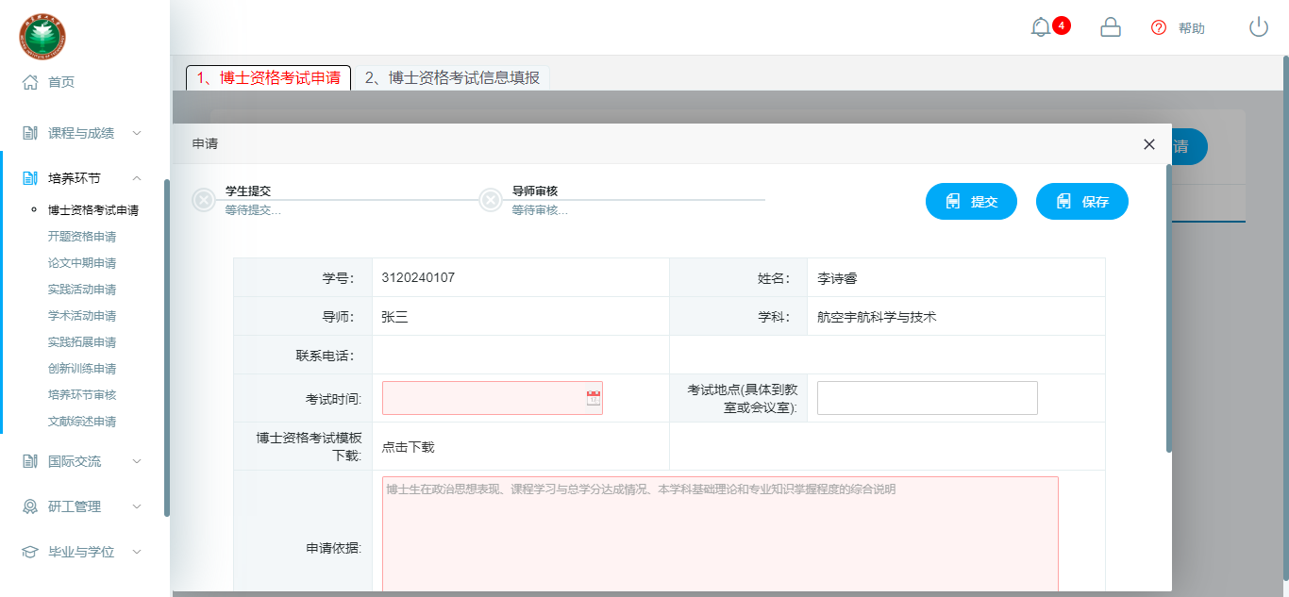
图：博士资格考试申请
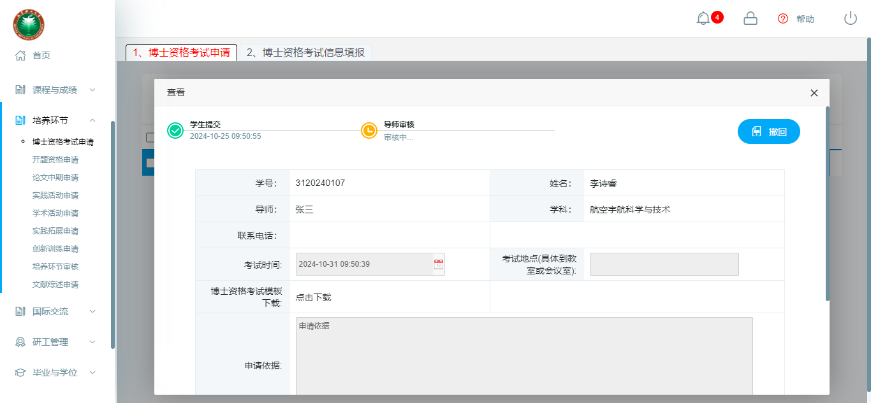
图：博士资格考试申请-撤回

1.2 To Fill Doctoral Qualification Examination Information
操作步骤
登录系统，点击【培养环节】→【博士资格考试申请】→【博士资格考试信息填报】。
操作说明
下图为博士资格考试信息填报页面。
点击【申请】维护申请内容，点击【暂存】保存申请内容；点击【提交】提交申请；
已保存的申请，点击操作栏的【编辑】、【删除】可修改、删除申请；
已提交的申请，鼠标移至审核状态，可查看审核流进度；点击操作栏的【查看】可查看申请。
1.2 To fill Doctoral Qualification Examination Information
Operation Steps
Log in to the system, click [培养环节] → [博士资格考试申请] → [博士资格考试信息填报].
Operation Instructions
The following is the page for filling doctoral qualification examination information.
Click [申请] to maintain the application content, click [保存] to save the application content; click [提交] to submit the application;
For saved applications, click [编辑] in the operation column to modify the application, or click [删除] to delete the application.
For submitted applications, move the mouse over the review status to view the review progress; click [查看] in the operation column to view the application.
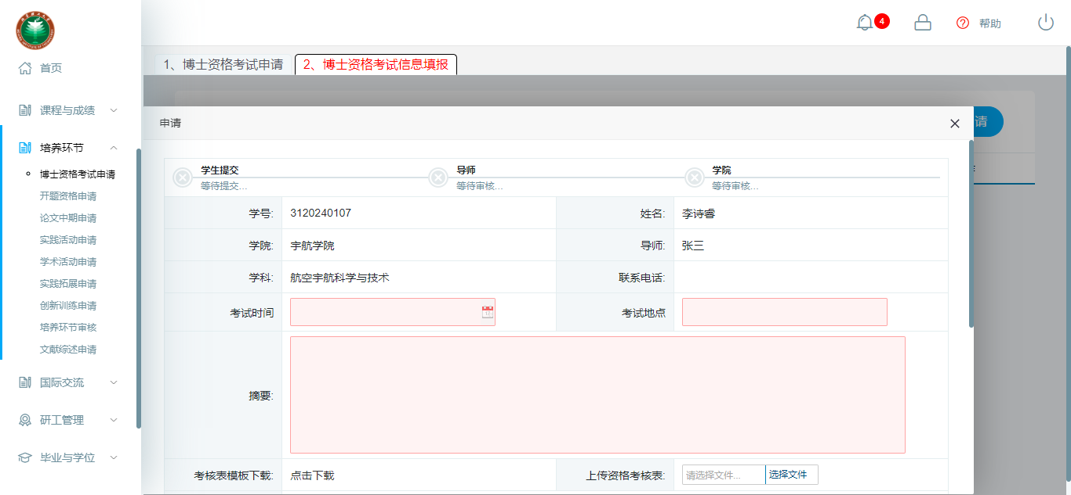
图：博士资格考试信息填报

